Girl Scouts of the Jersey Shore Sandy Hook Region

Girl Scout Family Ice Skating

241 Harmony Road, Middletown, NJ 07748

Girl Scouts, future Girl Scouts, their Families, and Friends,
Are Invite to a Fun Evening of Ice Skating!

Tuesday, March 20, 2018

6:00 – 8:00 p.m. Skating Time
Check in and get skate rentals starting at 5:30pm

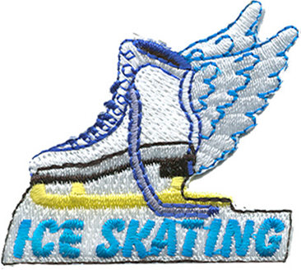

$10 per skater by March 16th

$15 at the door

includes skate rental & a patch (for Girl Scouts)
(All proceeds will be donated to GSJS Annual Giving)

*Adults not skating may observe from the bleachers
*All girls must be chaperoned by a parent or troop leader
*Walkers are for Daisy and Brownie Girl Scouts

REGISTER ONLINE:

https://tinyurl.com/iceskatinggirlscouts

